Software Requirements Specification

for

Guest House Booking in NITC

**Version 1.0**

**Prepared by**

**Team Number: 13**

|  |  |  |
| --- | --- | --- |
| **Palash Bajpai** | **B180759CS** |  |
| **Aditya Jha** | **B180648CS** |  |
| **Amit Kumar Panja** | **B180887CS** |  |
| **Ritik Gautam** | **B180630CS** |  |
| **Atul Singh** | **B180738CS** |  |

|  |  |
| --- | --- |
|  |  |
| **Course:** | **CS3004D Software Engineering** |
| **Date:** | **23 February 2021** |

**Contents**

**1 Introduction**3

1.1 Document Purpose 3

1.2 Product Scope 4

1.3 Intended Audience and Document Overview 4

1.4 Definitions, Acronyms and Abbreviations 5

1.5 Document Conventions 5

1.6 References and Acknowledgments 6

**2 Overall Description**7

2.1 Product Overview 7

2.2 Product Functionality 8

2.3 Design and Implementation Constraints 8

2.4 Assumptions and Dependencies 9

**3 Specific Requirements**10

3.1 External Interface Requirements 10

3.1.1 User Interfaces 10

3.1.2 Hardware Interfaces 12

3.2 Functional Requirements 12

3.3 Use Case Model 13

3.3.1 Check Availability 14

3.3.2 Make reservation 15

3.3.3 Set room rates 16

3.3.4 Guest Search 17

3.3.5 Add Guest

**4 Other Non-functional Requirements**19

4.1 Performance Requirements 19

4.2 Safety and Security Requirements20

**Appendix A - Activity Log**21

**Revisions**

|  |  |  |  |
| --- | --- | --- | --- |
| **Version** | **Primary Author(s)** | **Description of Version** | **Date Completed** |
| 1.0 | Palash, Aditya, Atul ,  Amit, Ritik |  | 23/02/2021 |

# 1 Introduction

The following subsections of the Software Requirements Specifications (SRS) document provide an overview of the entire SRS. The SRS will provide a detailed description of the requirements for the Guest House booking system. This system is developed specifically for the NITC. This SRS will allow for a complete understanding of what is to be expected from the system to be constructed. The clear understanding of the SRS and its functionality will allow for the correct software to be developed for the end user and will be used for the development of the future stages of the project. This SRS will provide the foundation for the project.

## Document Purpose

The Document is a Software Requirements Specifications (SRS) for the “**Guest House Booking**” application for NITC. It will explain the purpose and features of the system, lays out the functional and non-functional requirements, tells about the interfaces of the system, what the system will do, the constraints under which it must operate and how the system will react to external stimuli. This SRS is organized into several sections to help in the development and designing of the system and helps to get clear picture of app during the development stage. This document is intended to propose this software to consumer for their validation and clarification of the system.

This SRS will be used by the system development team which is constructing the Guest house booking system and the end users. The Project team will use the SRS to fully understand the expectations of this project to construct the appropriate software. The end users will be able to use this SRS as a “test” to see if the constructing team will be constructing the system to their expectations. If it is not to their expectations the end users can specify how it is not to their liking and the team will change the SRS to fit the end users’ needs.

1. This Hotel Management System Software Requirement Specification (SRS) main objective is to
2. provide a base for the foundation of the project. It gives a comprehensive view of how the system
3. is supposed to work and what is to be expected by the end users. Client’s expectation and
4. requirements are analyzed to produce specific unambiguous functional and non-functional
5. requirements, so they can be used by development team with clear understanding to build a system
6. as per end user needs.
7. This SRS for HMS can also be used for future as basis for detailed understanding on how project
8. was started. It provides a blueprint to upcoming new developers and maintenance teams to assist
9. in maintaining and modifying this project as per required changeabilit
10. This Hotel Management System Software Requirement Specification (SRS) main objective is to
11. provide a base for the foundation of the project. It gives a comprehensive view of how the system
12. is supposed to work and what is to be expected by the end users. Client’s expectation and
13. requirements are analyzed to produce specific unambiguous functional and non-functional
14. requirements, so they can be used by development team with clear understanding to build a system
15. as per end user needs.
16. This SRS for HMS can also be used for future as basis for detailed understanding on how project
17. was started. It provides a blueprint to upcoming new developers and maintenance teams to assist
18. in maintaining and modifying this project as per required changeabilit
19. This Hotel Management System Software Requirement Specification (SRS) main objective is to
20. provide a base for the foundation of the project. It gives a comprehensive view of how the system
21. is supposed to work and what is to be expected by the end users. Client’s expectation and
22. requirements are analyzed to produce specific unambiguous functional and non-functional
23. requirements, so they can be used by development team with clear understanding to build a system
24. as per end user needs.
25. This SRS for HMS can also be used for future as basis for detailed understanding on how project
26. was started. It provides a blueprint to upcoming new developers and maintenance teams to assist
27. in maintaining and modifying this project as per required changeabilit

## 1.2 Product Scope

This Guest House Booking is an application intended to make guest house booking system of NITC easy and better for all. . The Booking System is to keep track in room and room reservation and check availability. It will also handle guest details will handled by. It will allocate rooms in NITC guest house. If further requests came for a room then the room should be allotted based on the priority. The priority is given by the position of the requested person in NITC. Administration department will monitor this application .This system can be used by anyone who wants to book guest room in NITC, this application will be run by hostel management of NITC who manages the guest house. They can access to all system functionalities without any restrictions.

The objectives of the automated Guest House Booking System are to simplify the day to day processes of the guest house. The system will be able to handle many services to take care of all guest in a quick manner. As a solution to the large amount of file handling happening while booking room in guest house, this software will be used to overcome those drawbacks. Safety, easiness of using and most importantly the efficiency of information retrieval are some benefits the development team going to present with this system. The system should be user appropriate, easy to use, provide easy recovery of errors and have an overall end user high subjective satisfaction.

## 1.3 Intended Audience and Document Overview

This SRS is intended for several audiences, including inmates of institute, hostel management staff, warden of guest house, one who wants to book room in guest house, system designer and developers.

1. This SRS will help hostel management staffs who manage our NITC guest house to see if application is developing according to their needs.
2. The developer would be benefited by knowing the requirements of client.
3. The designer can use this SRS to design the system to meet all requirements.
4. The admin can get idea of their role and special features they are provided.
5. The database designer can use this for designing database according to needs of project.

Brief outline of the document is,

1. Overall Description
2. System Features
3. External Interface Requirements
4. Non Functional Requirements

## 1.4 Definitions, Acronyms and Abbreviations

Admin: One who have all access to the application. He will be able to see database of application and other features.

Client: One who request for the application to be made. This case it is NITC guest house management staff.

User: One who interact with the application.

|  |  |
| --- | --- |
| App | Application |
| Db | Data Base |
| GHB | Guest house booking |
| SRS | System Requirements Specification |

## 1.5 Document Conventions

## The document is prepared using Microsoft Word and has used the font type 'Cambria'. The fixed font size that has been used to type this document is 14pt with 1.15 line spacing. It has used the bold property to set the headings of the document. UML diagrams have been created according to UML 2.0 standards. Standard IEEE template is the template used to organize the appearance of the document and its flow.

## 1.6 References and Acknowledgments

1. RaguRamakrishnan/JohnesGehrke,*Database Management Systems 3rdedition*.McGrow-HILL,2003.
2. <https://ieeexplore.ieee.org/document/278253> - IEEE Guide for Software Requirements Specifications.
3. <https://www.quickfms.com/guest-house-management-software> - To see what features to add in application

# 2 Overall Description

## 2.1 Product Overview

This Guest House booking system app is a new self-contained software product which will be produced by the project team in order to overcome the problems that have occurred due to the current manual system. This will replace the current system of form filling and submitting to hostel management of NITC who then allocate the room to guest. The newly introduced system will provide an easy access to the system and it will contain user friendly functions with attractive interfaces. The system will give better options for the problem of handling large scale of physical file system, for the errors occurring in calculations and all the other required tasks that has been specified by the client. The final outcome of this project will increase the efficiency of almost all the tasks done while booking room in a much convenient manner.

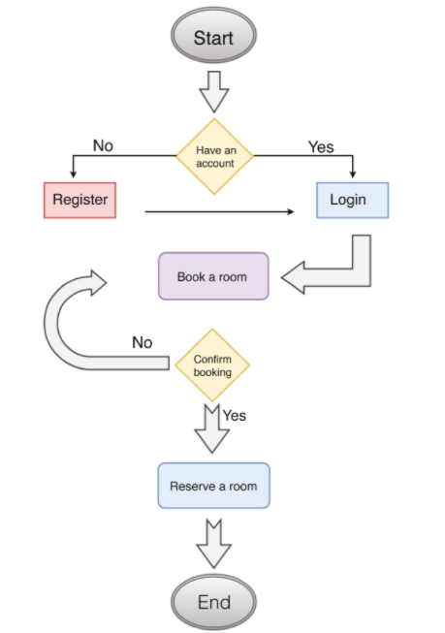

Working of application from end user perspective

## 2.2 Product Functionality

1. Search Rooms in guest house
2. Book a room
3. Make Payment
4. Issue Bills
5. Set Rates for rooms
6. Email Notifications
7. Issue priorities to end user according to their position in NITC
8. Manage Users(Add, Update, Delete)
9. Manage Guest (Add, Update ,Delete)

## 2.3 Design and Implementation Constraints

1. Availability: The application must be running all day long.
2. Only specific users will have ability to handle admin task and database of application. These rights will be given by app developer.
3. Admin have control who books the room and take necessary decision accordingly.
4. Users must be enabled to access the website and login with their respective username and password credentials only.
5. Implementation of the database using a centralized database system.
6. The challenges in developing the product will involve scaling it to the required number of stakeholders. So providing fast request response time will be a necessity.
7. User will be able to see only details of available rooms.
8. If further requests came for a room then the room should be allotted based on the priority. The priority is given by the position of the requested person in NITC.
9. It may be decided to keep only NITC students and staff can login app using their college id. This feature should be included if required by database manager in the application.

## 2.4 Assumptions and Dependencies

1. Database manager and admin must be from the NITC.
2. Decision related whom to allocate room is taken by hostel management committee.
3. Decisions regarding pricing of room are taken by admin.
4. If required only NITC faculties, staff and students will be allowed to book a room. In such cases their college email id and password will be used to login to application.
5. Language used to communicate for the app is English.
6. All users must have an email and password for the account.
7. Internet connection is mandatory.

# 3 Specific Requirements

## 3.1 External Interface Requirements

### 3.1.1 User Interfaces

* Home page of application

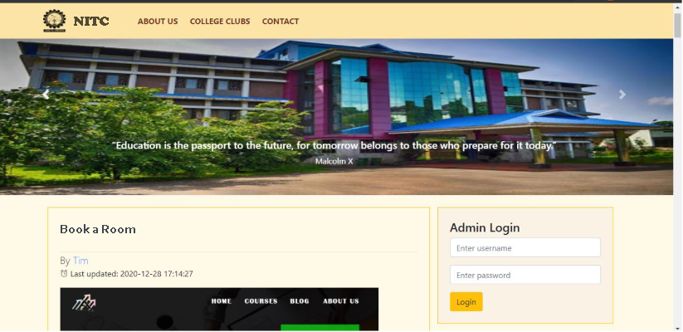

* Dashboard

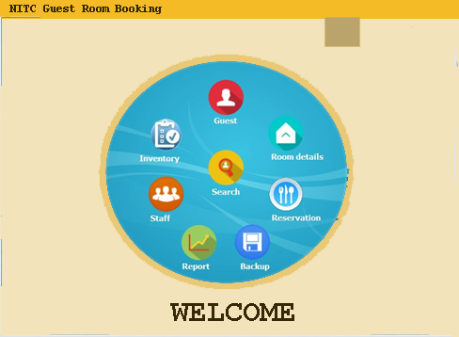

* Add user

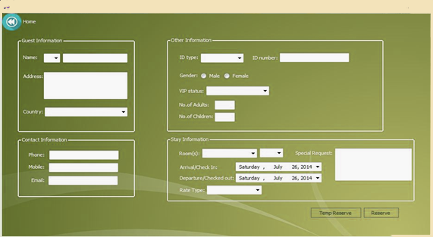

* Add Admin

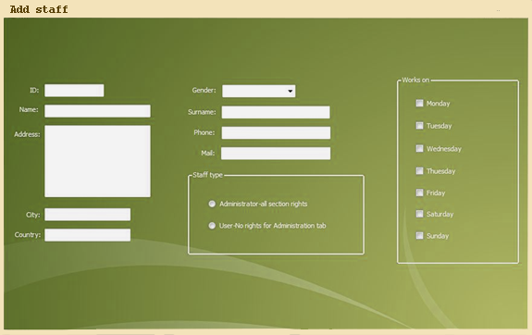

### 3.1.2 Hardware Interfaces

* Since the application runs over the internet, the system must always be connected to the internet.
* Backup storage for retrieval of data in case of unexpected failures.
* A laser printer will be needed when printing bills and several reports
* Laptop or mobiles to access the application are required.

## 3.2 Functional Requirements

* Add guest: - Details like Phone number, Company, Name, E-mail, Gender and Address are taken and then details are validated and then information is recorded in the database of application.
* Display and search rooms:-Search room according to pricing , availability etc. Display all rooms available at a given time period.
* Make Reservations:-Select the room user wants to book. See pricing and make payment.
* Issue Bills:-If payment for the room is made, sends email to the user and also provide pdf of the bill.

## 3.3 Use Case Mode

### 3.3.1 Check Availability

**Author –** Atul Singh

**Purpose** - To check whether a room available or not

**Priority** – Has high priority. It checks the availability of rooms in given time period. Only available rooms can be booked by the users.

**Preconditions** – Users who is login to the system can see the room availability.

**Post conditions** – Details of available room is retrieved from the database and displayed to user.

**Actors** – User who wants to book a room or Receptionist of guest house who books it for others

**Flow of Events**

1. Display User interface.
2. Select Availability Tab
3. Enter room type, duration, number of adults and children
4. System check room availability relevant to each requirements
5. Display available room details

**Notes/Issues** – If no room available for entered details and display “No Room Available”.

### 

### 3.3.2 Make Reservation

**Author –** Aditya Jha

**Purpose** - Add a new reservation

**Priority** – Has high priority. As this is the basic functionality our application will be performing.

**Preconditions** – Guest shouldn’t already exists.

**Post conditions** - Hotel Guest Details updated to include current Guest. Also the room status will be changed to booked.

**Actors** – User who wants to book a room or Receptionist of guest house who books it for others

**Flow of Events**

1. Guest login to application.
2. System searches for room details.
3. Room types and availability is displayed.
4. Payment for the room is done.
5. System updates room details and add the guest.
6. Booking is confirmed through a mail on customer email.

### 3.3.3 Set Room rates

**Author –** Ritik Gautam

**Purpose** – Set rates to different types of room available in guest house. Set prices according to age of guest also if required.

**Priority** – Has low priority. As this task is normally performed during a period of one to two years.

**Preconditions** – User who have admin credentials only can perform this task.

**Post conditions** – Changes made in rates should be applied to all rooms and displayed in the application as fast as possible.

**Actors** – This task can only be performed by the admin. For our system admin is hostel management committee since they handle guest house of NITC.

**Flow of Events**

1. Login through admin credentials.
2. Display room management window in admin panel.
3. Select type of room whose rate has to be changed.
4. Change the rates of selected types of rooms.
5. Update database.
6. Display “Successful” message if changes made successfully else display error message.

**Extends** - If room rates set previously clear them and redirect to set room rates

### 3.3.4 Guest Search

**Author –** Amit Kumar Panja

**Purpose** – Search a guest. If required modify or delete guest details.

**Priority** – Has medium priority.

**Preconditions** – Can be done only by receptionist and admin.

**Post conditions** – If changes are made for the given user then it should be updated in database.

**Actors** – This task can only be performed by the admin and receptionist.

**Flow of Events**

1. Login through admin credentials.
2. Open the Guest management panel.
3. Select search option.
4. Enter guest name.
5. If user is present display his/her details.
6. If want to delete guest click delete or can modify using update.
7. If guest not available show error message.

**Extends** - Update and modify guest details.

### 3.3.5 Add Guest

**Author –** Palash Bajpai

**Purpose** – Add a new guest.

**Priority** – Has high priority since guest from our database are only allowed to make reservation,

**Preconditions** –Guest should not be already present in the database.

**Post conditions** –Adding new guest updates the database.

**Actors** – This task can be performed by the receptionist if guest books room at office or user can directly use app and signup there to use the application.

**Flow of Events**

1. Select Signup option login/signup panel.
2. Signup ask for guest details, enter them.
3. After filling all details submit it.
4. Email conformation is send to user’s email id.
5. If details are validated, new guest is added to the database.
6. User can login to app using the details provided while signing up.

**Notes/Issues** – If wrong details are entered by user which do not match with syntax, or if some details are not entered then user won’t be able to sign up for the application.

# 4 Other Non-functional Requirements

## 4.1 Performance Requirements

Although the system is developed suiting for the least system performances, the performance of the system will highly depend on the performance of the hardware and software components of the installing computer. A server is required to run this web application. The request response time will depend on network speed and latency of the server. So, a server capable of handling approx 1000 concurrent requests is required. The application load time depends on speed of internet connection and proximity from the server.

## 4.2 Safety and Security Requirements

There are several user levels in hotel management system, Access to the various subsystems will be protected by a user log in screen that requires a user name and password. This gives different views and accessible functions of user levels through the system. Maintaining backups ensure the system database security. System can be restoring in any case of emergency. Users have option to save their login credentials. All Users have unique id and passwords. Password will be hidden while typing. Sign out and change password features are given to users.

## 4.3 Software Quality Attributes

1. Reliability

● New updates in database are reflected without any delay.

● Any registration by the user is reflected in database almost instantly.

● Application is made to protect inside information from users, only few selected people have access to handle all features of application

2. Usability

● In case of invalid situations an error message pops up on the screen, directing the user so as to resolve the issue.

.● This application is responsive, so works great with every size of screen.

3. Correctness

● To provide only reliable content in the post only few people are allowed to handle admin panel.

● Admin have full control to database. So he can make any changes if needed.

4. Maintainability

● Backup of database will be kept.

● SQL server would be having database maintenance routine scheduled monthly.

● Periodic testing and debugging will be done based on users and admins feedbacks.

● In case of any error, re-initialization of program will be done.

# Appendix A - Activity Log

**Meeting details**

* 1. 14 February 2021:- from 5PM to 7PM
  2. 19 February 2021:- from 8PM to 10PM
  3. 23 February 2021:- from 2PM to 6PM

**Individual contribuitions**

* 1. Ritik Gautam:- Deciding features to be added in application, Defining document purpose, Product scope, setting conventions for the document and a use case.
  2. Aditya Jha:- Described product overview and to decided functionality to be included. Defined the constraints to be included in the application. And made a use case.
  3. Palash Bajpai:-Designed the user interface for the application using photoshop, Also made use case model for the application, defined hardware interfaces and a use case.
  4. Atul Singh:- In the application defined assumptions made in the SRS and found dependencies. Also wrote functional requirements for the SRS. Designed a use case also.
  5. Amit Kumar Panja:- Wrote one use case and defined non-functional requirements of the SRS which included performance requirements, Safety and security requirements and software quality attributes.